Pfsense Firewall
Right now , our Windows 10 VM gets its internet directly from VMware. We need to break that connection and force Windows 10 to get its internet through pfSense.

The "Why": The Guard and the Detective
Think of pfSense as a very strict security guard standing at the front gate. The guard is great at stopping bad guys, but he only cares about what is happening right now.
Think of Wazuh as the lead detective sitting in the camera room.
If we don't connect them, the guard (pfSense) might block a Russian IP address, but the detective (Wazuh) will never know it happened. By connecting them, pfSense sends a continuous stream of reports (Syslogs) to Wazuh. Wazuh can then look at the big picture, store the evidence, and alert you if a coordinated attack is happening.
Now we need to start it.

Step 1: Create the pfSense Virtual Machine
- Open VMware Workstation on your Ubuntu host.
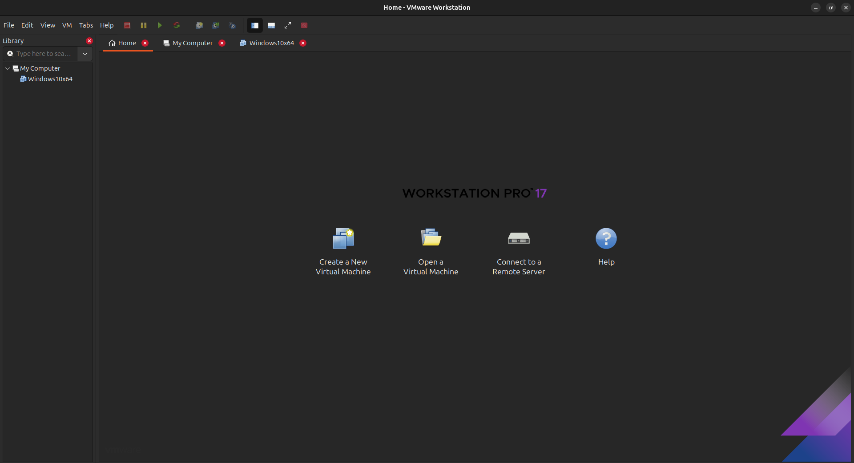
- Click File > New Virtual Machine.
- Choose Typical and click Next.
- Select your downloaded pfSense ISO file.
- Crucial Step: When it asks for the Guest Operating System, choose Other and select FreeBSD 64-bit (pfSense is built on FreeBSD, not Linux).
- Name it "pfSense Firewall" and give it at least 1GB of RAM and 10GB of disk space.
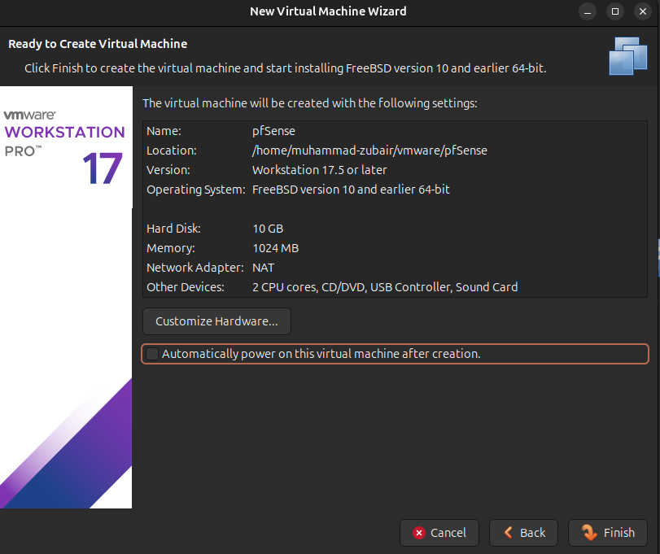
Click Finish. (Do not power it on yet!)

Step 2: Configure pfSense Network Adapters (The "Doors")
We need to add a second "door" to this VM.
- Right-click your new pfSense VM and go to Settings.
- Look at the hardware list. You will see one Network Adapter. Set this one to Bridged or NAT (This is your WAN / Internet connection).
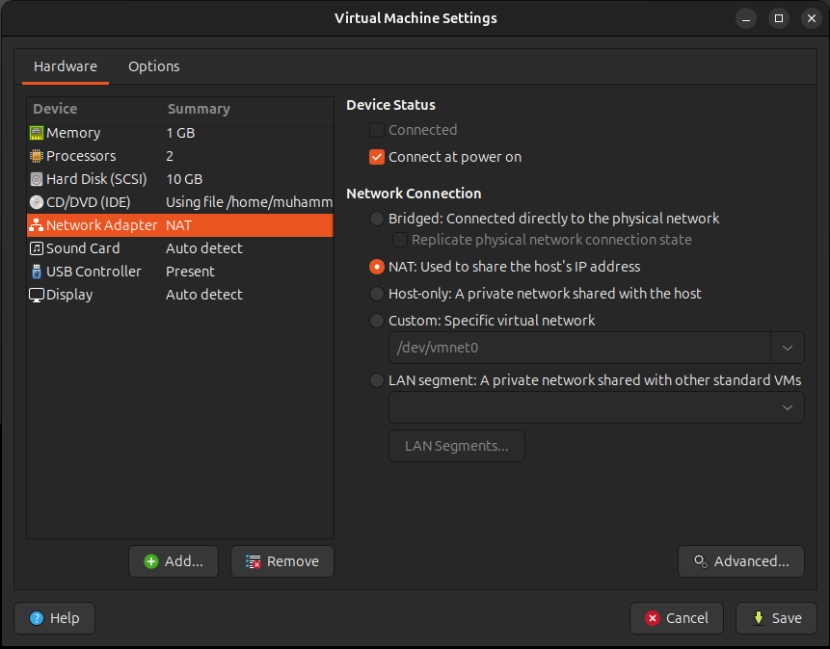
- Click the Add... button at the bottom.
- Choose Network Adapter and click Finish.
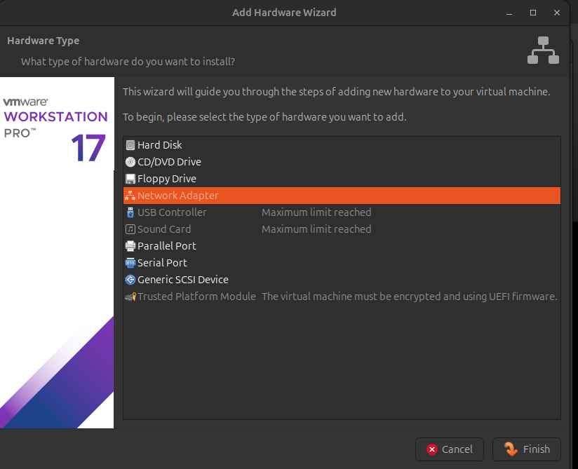
Click on Network Adapter 2 (your LAN interface).
At the bottom of the network options, select the radio button for the LAN segment (it is right under "Custom").
Click the LAN Segments... button below it.
Click Add, type a name like SOC-LAN, and click OK.
Now, click the dropdown menu under "LAN segment" and select your new SOC-LAN.
Click Save or OK.
Also Check both radio button of Device Status (Connected and Connect at power on)
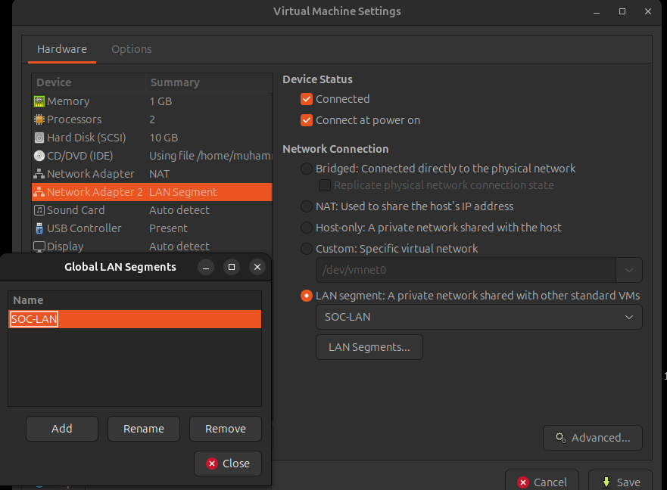

The Final VMware Step (Trapping Windows 10)
Now that pfSense has its "inside door" (Host-only), we need to put your Windows 10 machine behind it.
Go to your Windows 10 VM Settings.
Click on Network Adapter.
Change the connection type to LAN segment.
Click the dropdown menu and select the exact same SOC-LAN.
Make sure both Connected and Connect at power on are checked at the top.
Click Save or OK.
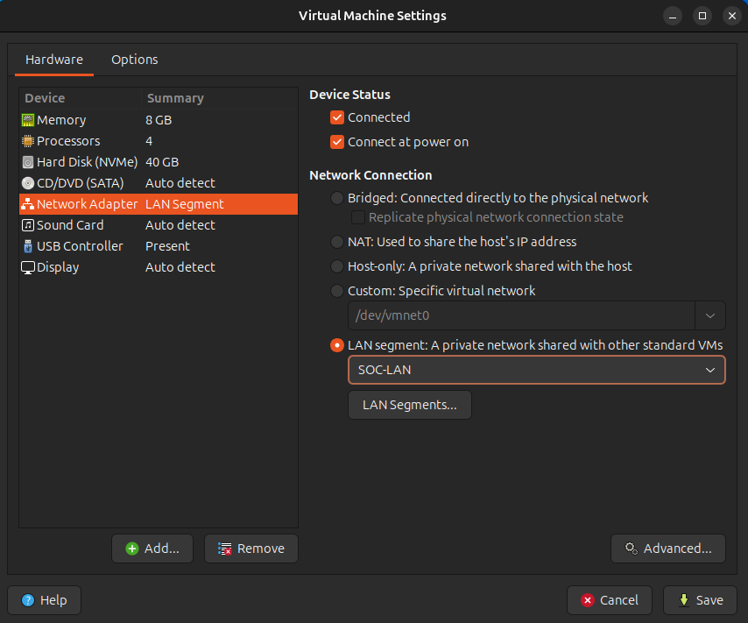
Once you have done this for both VMs, your VMware wiring is complete!. You are ready to power on the pfSense VM and start the installation process.
Installation Process of pfSense
When you power on the VM, you will see a black terminal screen with white text, which will eventually turn into a blue menu. Since pfSense is based on FreeBSD Linux, there is no mouse—you will only use your Arrow Keys and the Enter key.

Step 1: Boot Up
- Power on your pfSense Virtual Machine in VMware.
- It will show a boot menu with a countdown. Just wait; it will automatically start booting after a few seconds.
Step 2: The Installation Menus
- Copyright/Trademark: You will see a blue screen with text. Press Enter to Accept.
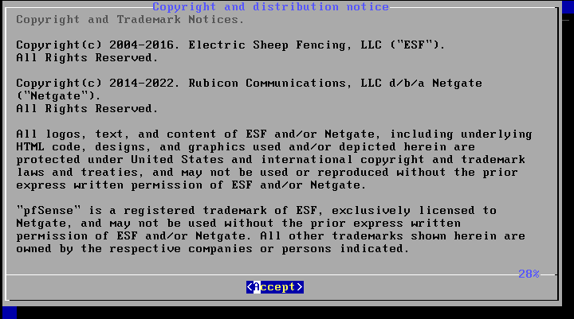
- Welcome Screen: Select Install and press Enter.
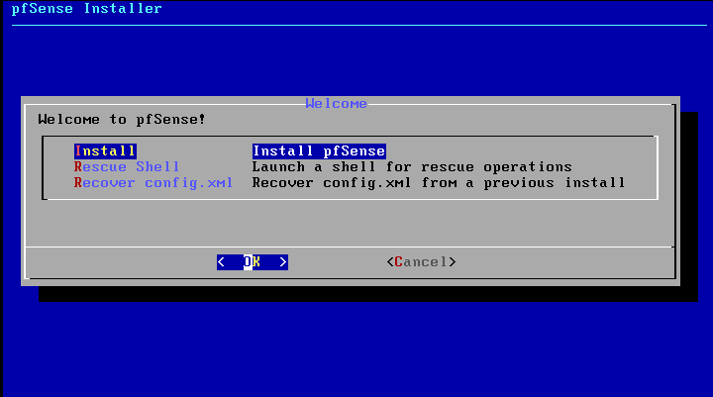

- Keymap Selection: Select Continue with default keymap (US English) and press Enter.
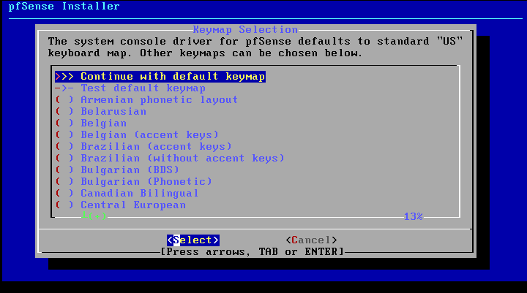
- Partitioning: Select Auto (ZFS) (this is the modern, secure file system) and press Enter.
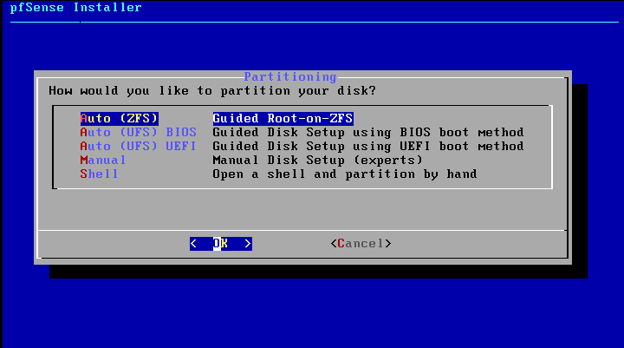
Look closely at the second line in your screenshot. It says T Pool Type/Disks: stripe: 0 disks.
Because it says "0 disks", the installer does not know where to put the operating system yet. If you press "Install" right now, it will give you an error. We have to select the hard drive first.
- Select the Pool: Press your Down Arrow key to highlight T Pool Type/Disks: and press Enter (or just press the letter T on your keyboard).

- ZFS Configuration: Select Install -> Stripe (No Redundancy)
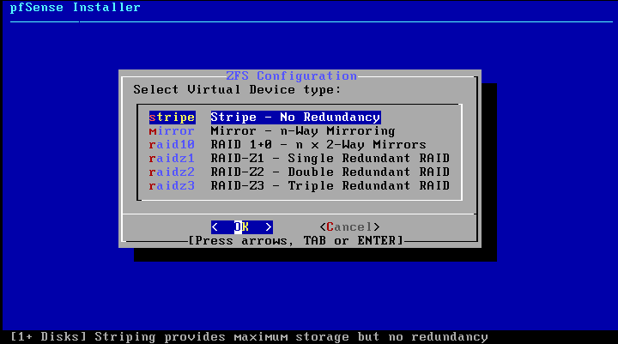
- Use the Spacebar to select your da0 VMware virtual hard disk (an asterisk * will appear next to it) -> Press Enter -> Select YES to destroy data and format the disk.
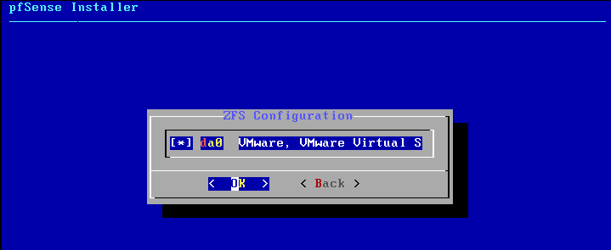
If you are seeing the following screen.You successfully selected the hard drive.
Start the Install: Use your Up Arrow key to highlight >>> Install at the very top of that list, and press Enter.
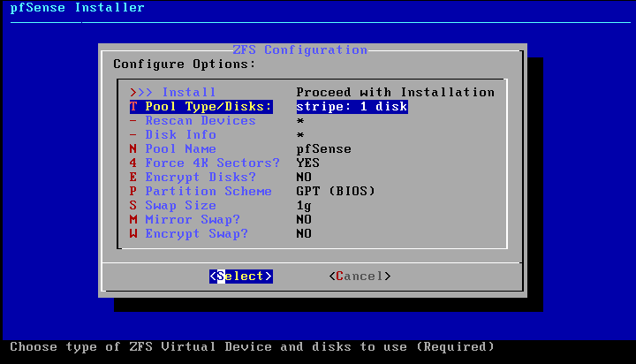

Confirm Destruction: A red warning screen will pop up asking if you are sure you want to destroy all data on the disk. Use your arrow keys to highlight YES and press Enter.
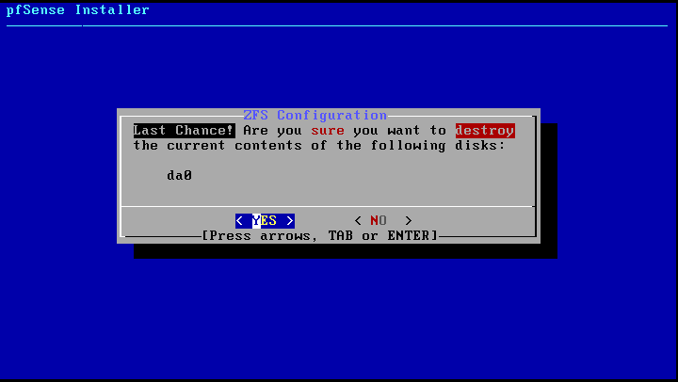
Wait: The installer will now copy the pfSense files to your virtual hard drive. This usually takes about 1 to 2 minutes.
The Shell Prompt: When it finishes, it will ask if you want to open a shell to make any final manual modifications. Select NO and press Enter.
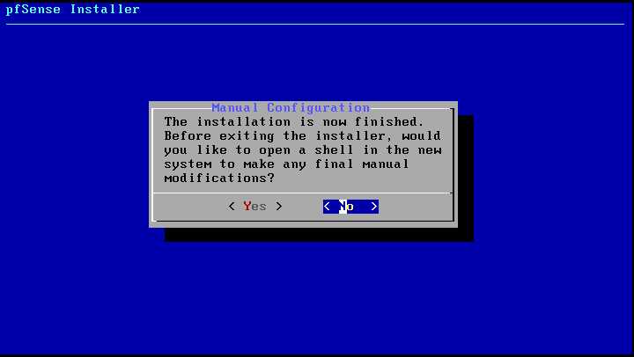
Reboot: Finally, it will ask you to reboot. Select Reboot and press Enter.
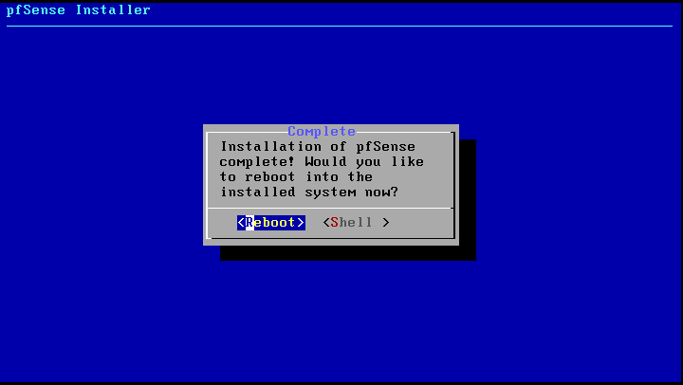

⚠️ CRITICAL VMWARE STEP (Do this during the reboot!)
As soon as the screen goes black for the reboot, you need to "eject" the installation CD. If you don't, it will just boot back into the installer from the beginning.
- Quickly go to the top VMware menu.
- Click VM -> Removable Devices -> CD/DVD -> Disconnect.
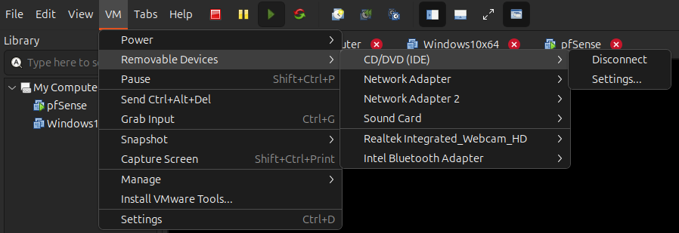
Once it boots up from the hard drive, it will do some initial automated configuration.
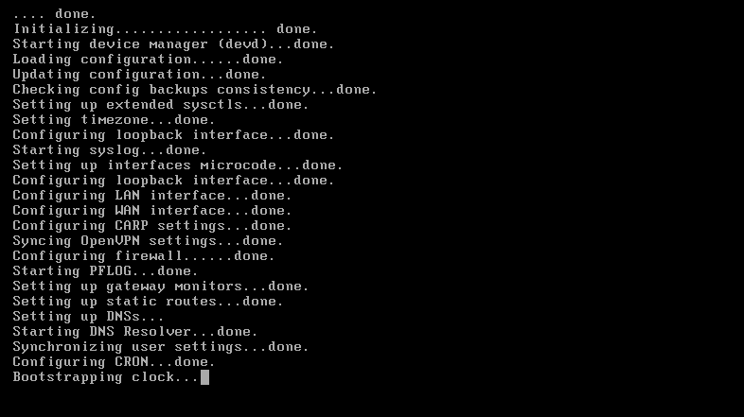
Let the installation finish, and when you have successfully rebooted and see the final pfSense menu (with options 0-16)!
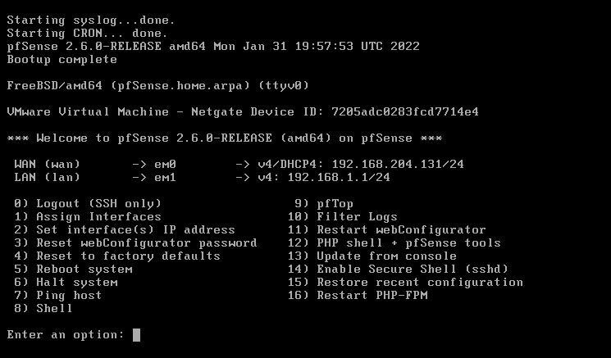
Understanding Your New Firewall (The Console)
Look closely at your final screenshot. It gives us the two most critical pieces of information for the rest of this project:
- WAN (em0): 192.168.204.131. This is pfSense's connection to the "outside" world (your Ubuntu host and the actual internet).
- LAN (em1): 192.168.1.1. This is the private, secure "inside" network. This IP address is the pfSense Default Gateway.
From this point on, you will rarely use this black console screen. Almost all configuration is done through a graphical web browser interface (the WebGUI).

Step 1: Access the Firewall Dashboard
Because we trapped your Windows 10 machine on the inside network (the LAN) earlier, it should now be getting its network connection directly from pfSense.
- Leave the pfSense VM running in the background.
- Switch over to your Windows 10 Virtual Machine.
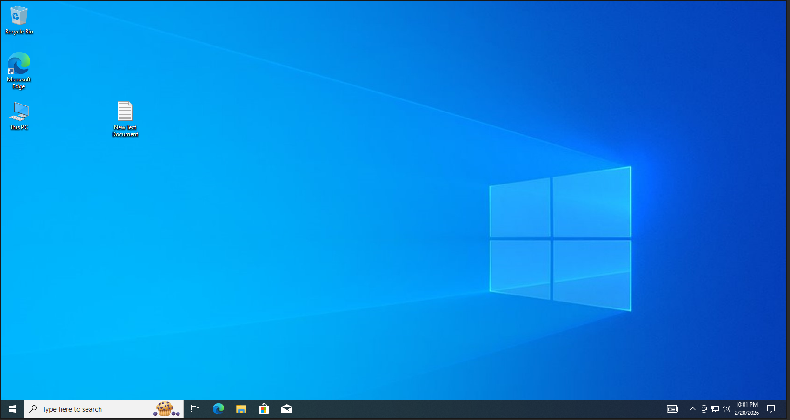

Test the Connection
Now that they are hardwired together on their own private segment, go back into your Windows 10 virtual machine.
- Open a web browser inside Windows 10 (Edge, Chrome, or Firefox).
- In the address bar, type exactly: https://192.168.1.1 and press Enter.
- Security Warning: You will get a warning that your connection is "Not Private" or "Not Secure." This is perfectly normal for a home lab because it uses a self-signed certificate. Click Advanced, and then click Proceed to 192.168.1.1 (unsafe).
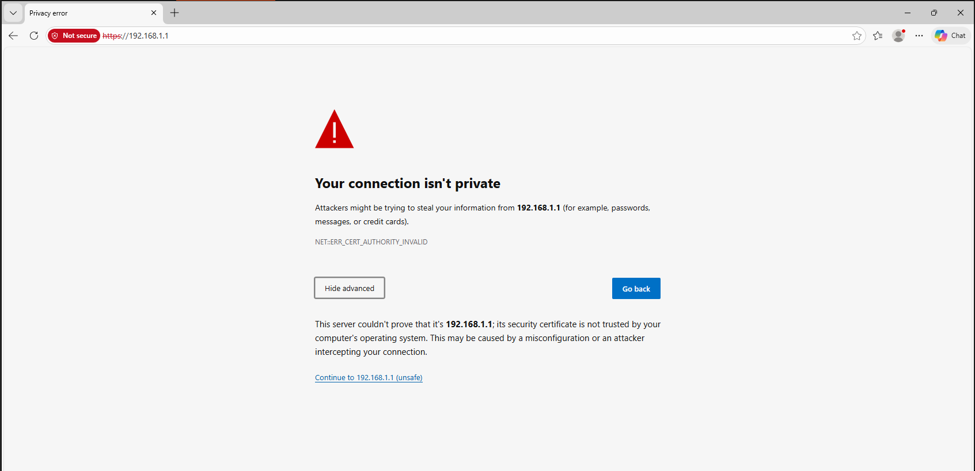

Step 2: Log In
You should now see the pfSense login screen!
- Username: admin
- Password: pfsense

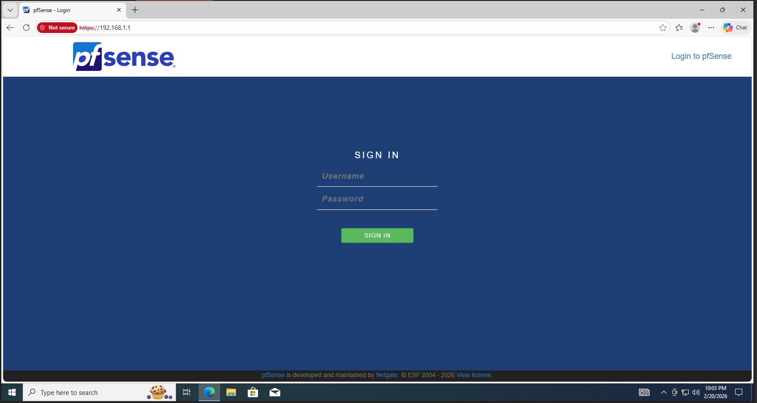
Here you can see that the Dashboard of pfSense are shown :
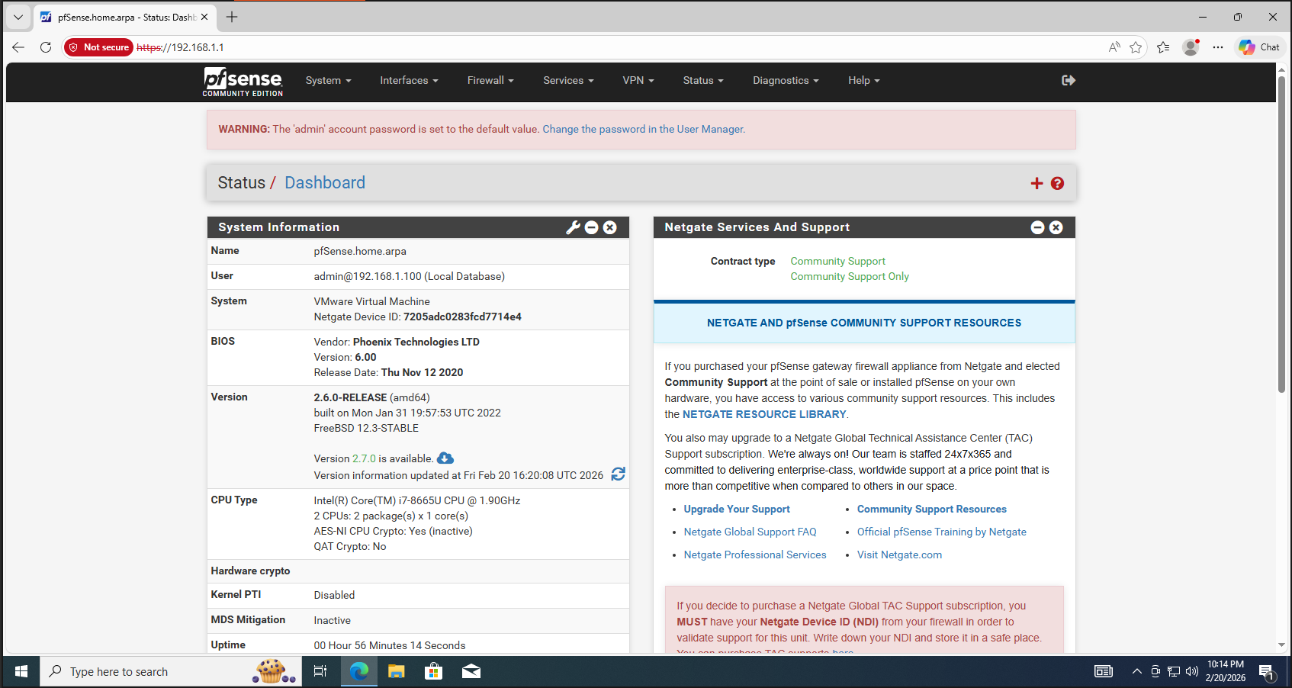
In our next documentation we will explore more about pfSense Firewall.

